

CITY OF DETROIT PLANNING COMMISSION

HEARING MINUTES
Tuesday, October 21 , 2025
5:30 PM
345 Santiam Ave., Detroit, OR
Zoom ID: 852 1613 1651
Pass: 581179

CALL MEETING TO ORDER – In the absence of Chairman Kevin Cameron, Adam Snyder opened the meeting at 5:41 PM.

- ROLL CALL – Present via Zoom – Nancy Powell, Adam Snyder, Teresa Maurmann, Chris Storey and Bill McCall. Absen with notice – Kevin Cameron and Gina Audritsh Staff Present via Zoom – Michelle Connor

- DECLARATIONS OF CONFLICT OF INTEREST AND EX-PARTE CONTACT - None Conflict of Interest indicates a direct/indirect financial benefit, as defined by Oregon Government Standards and Practices Commission, from an agenda item and excludes any involvement in discussion or vote on the issue.
Where a Councilor or Planning Commissioner is so involved with an issue such that they have prejudged the matter based on evidence or opinion not developed during the course of the record proceeding before the city, and it would be unfair for that official to vote on the application, that official should also exclude him/herself from any involvement in discussion or vote on the issue.

- ANNOUNCEMENTS - Items not on the agenda but relevant to City business may be discussed by the Planning Commission at this meeting. Citizens are encouraged to attend all meetings of the Planning Commission to ensure that they remain informed. Agenda items may be moved back if a Public Hearing is scheduled.- None

- ORDER OF BUSINESS

  - Public Hearing – VAR 2025-01 – Variance to Section 2.1.5(B)(2) of the Detroit Development Code (DDC) to reduce the side yard setback from five (5) feet to approximately 3 feet for the yard along the northern property line to allow the construction of an accessory structure in their rear yard setback.

Adam Snyder opened the Public Hearing at 5:43 PM. City Planner, Mcrae Carmichael read the Staff Report. During public testimony, Amanda Green spoke in opposition and read a statement she says was e-mailed to Mcrae & Michelle that was never received by
either party. Property owner, Ken Foote, joined the meeting and clarified that the shop is only 450 sq. ft. and not 5,000 sq. ft. Adam Snyder closed the Public Hearing at 6:43 PM. Chris Storey made a motion to continue the Hearing on November 4, 2025 at 5:30 to evaluate what they are building like the pitch and the size of it so the Commission can further determine whether they will approve this or not, seconded by Teresa Maurmann, all in favor, motion passed unanimously. Kevin Cameron & Gina Audritsh were absent with notice.

- APPROVAL OF MINUTES of June 24, 2025– Nancy Powell made a motion to approve the minutes, seconded by Chris Storey, all in favor, motion passed unanimously. Kevin Cameron and Gina Audritsh were absent with notice.

- NEXT SCHEDULED MEETING: Continuation of Hearing November 4, 2025

- ADJOURNMENT – Nancy Powell made a motion to adjourn, seconded by Teresa Maurmann, all in favor, motion passed unanimously.

Signed:

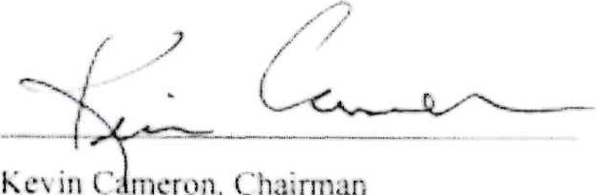
in
C
meron,

Attest:



Michelle Connor, City Recorder

